**Sri A.S.N.M. Government College (Autonomous)Palakol, West Godavari District - 534260**

|  |  |
| --- | --- |
| C:\Users\kk\Desktop\Dept. of Commerce\Website\Images\new logo.jpg | **Department of Economics** |

**DIGITAL CLASS BY DEPARTMENT OF ECONOMICS: 13-05-2022**

The Department of Economics used ICT Tools to teach the class in Digital Class room. Economics Lecturer Dr.Ch.Usharani explained the “Various Concepts of National Income” to 1 ST Year, Second Semester B.A Students on 13-05-2022. All the 1st year B.A students attended in this class.

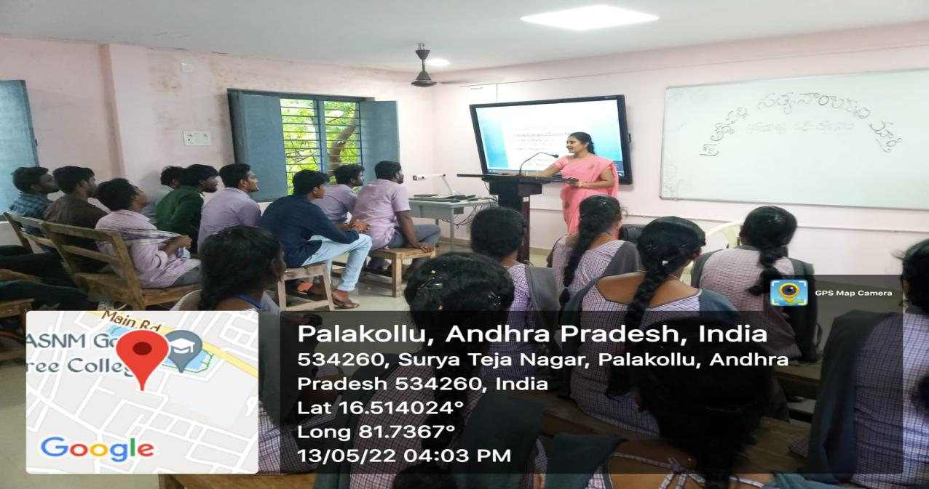

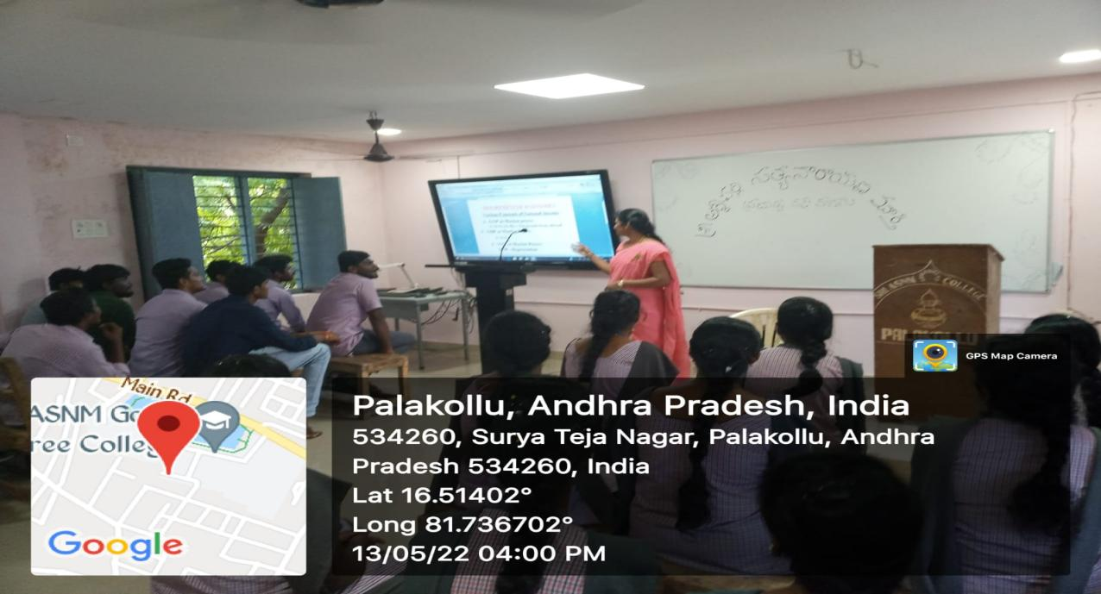

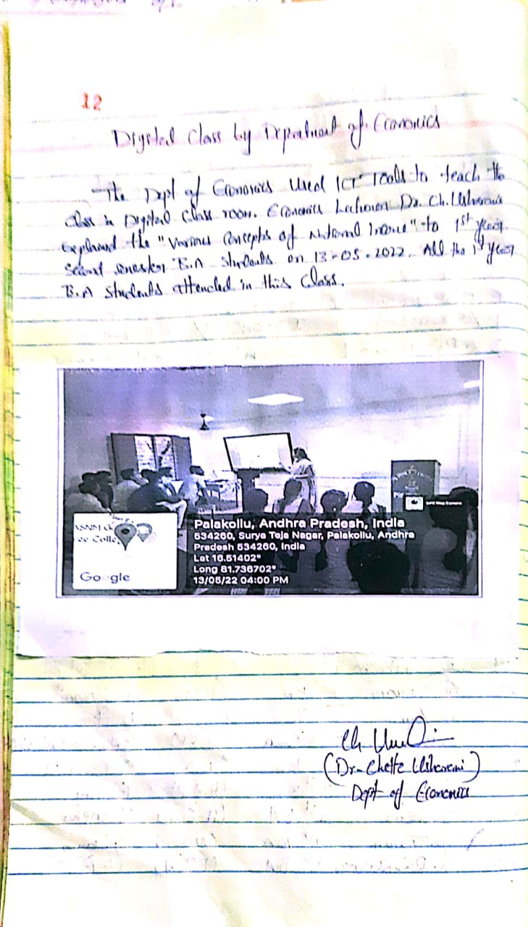

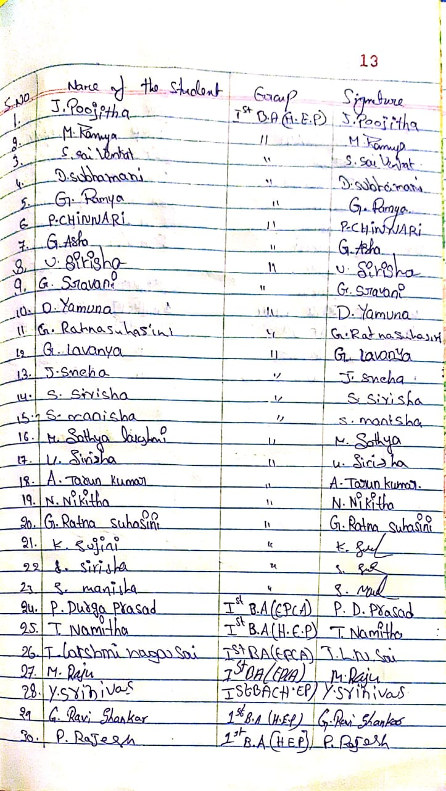

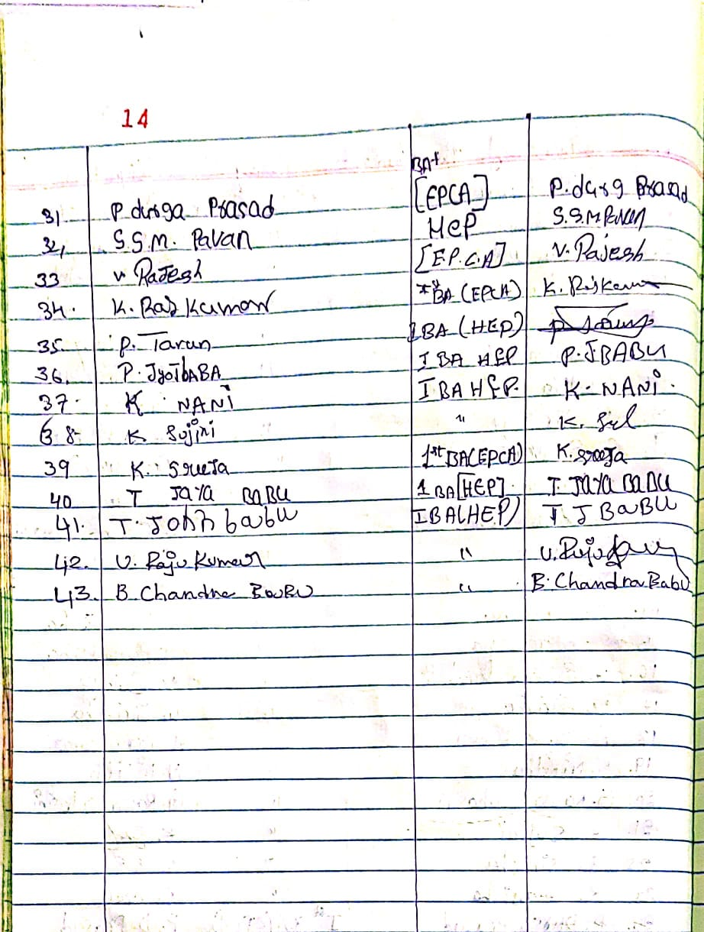

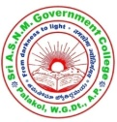**Sri A.S.N.M. Government College (Autonomous)**

**Palakol, West Godavari District - 534260**

**Department of Economics**

**ICT Based Class Room Teaching by Department of Economics:22-08-2022**

The Department of Economics conducted class by using ICT tools on 22-08-2022 in B.A digital class Room. The Economics Lecturer Dr.V.Vijaya Lakshmi conducted ICT based class for II B.A (HEP,HET) students. She conducted motivational class on exam preparation on Paper-IV “NITI AAYOG”. She also revision and discussion model papers while using ICT tools is very useful for students. There are 32 students were attended for this class.The concept explained while using ICT tools is very useful while understanding the concept to students.

.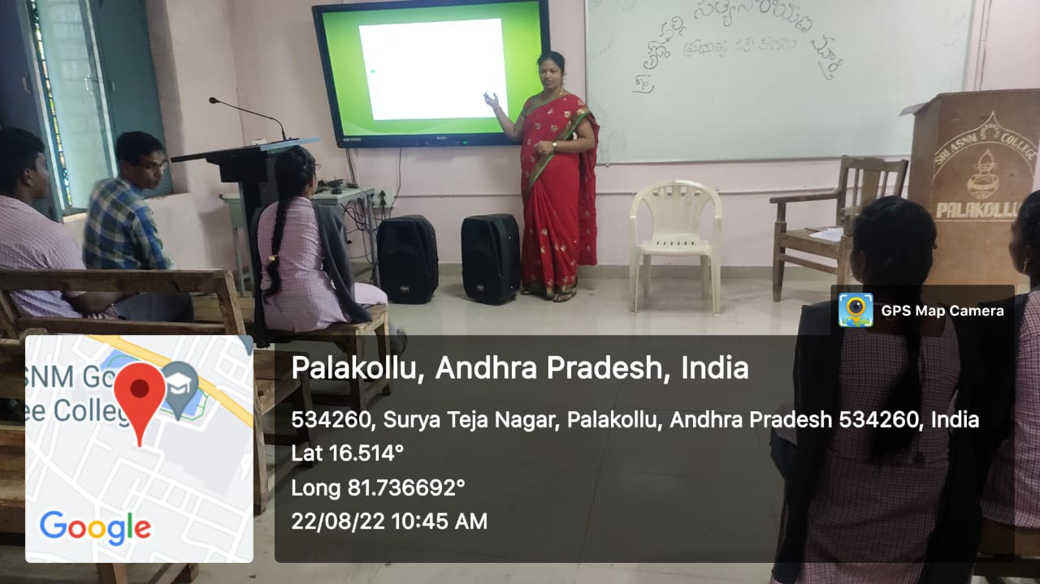

**Sri A.S.N.M. Government College (Autonomous)**

**(NAAC Re-accredited by ‘B’ Grade with 2.61 CGPA)**

**Palakol, West Godavari District - 534260**

**Department of Economics**

**ICT Based Class Seminar by Department of Economics: 22-08-2022**

The Department of Economics conducted class seminar by using ICT tools on 22-08-2022 in B.A digital class Room students are actively participated in this seminar. The Economics Lecturer Dr.V.Vijaya Lakshmi conducted ICT based class seminar for II B.A (HEP,HET) students.Students are very happy about conducting this type of activity to improve their skills.M.Raj Kumar,M.Sirisha and P.KamalaII BA student gave a seminar by using PPT . They explained about the topic Agricultural sector in India.

